**2025 May Day MCM**

**Problem A. Branch Road Traffic Flow Estimation Problem**

In the road network, main roads are usually equipped with traffic flow monitoring devices, which can record the traffic flow data of the main roads in real time. When multiple branch roads converge into the main road, since some branch roads lack traffic flow monitoring devices, the traffic flow of each branch road needs to be estimated by combining the traffic flow data from the main road with the history trend information of the branch roads. It will provide data and methodological support for issues such as optimizing the timing of traffic signals, alleviating traffic congestion and planning road resources.

In this problem, it is assumed that: (1) The traffic flow on the main road is the summation of the traffic flow on each branch road, and the traffic flow on each branch road has a certain regularity (such as the varying traffic flow patterns during morning and evening rush hours, as well as off-peak times), and this regularity can be described by a function. (2) All the roads are one-way lanes. The blue arrows in Figures 1 to 3 represent the direction of traffic flow. (3) In Questions 1 to 4, the "increase/decrease" trends of traffic flow all refer to the "strictly monotonic increase/strictly monotonic decrease" trends. "Stable" means that the traffic flow is stable at a certain fixed non-negative constant, and the functional relationships of traffic flow changes on each branch are all continuous functions. (4) The record data of vehicle flow has been converted into the number of standard vehicle equivalents. The vehicle flow in each question refers to the number of standard vehicle equivalents, which can be any non-negative real number without considering the unit of vehicle flow. Please establish the mathematical model according to the Attachment and complete the following questions:

**Question 1:** Consider the Y-shaped road shown in Figure 1, where the traffic flow of Branch road 1 and Branch road 2 converges simultaneously into Main road 3. Suppose that only the traffic flow monitoring device A1 is installed on the Main road 3, and the traffic flow information of the main road is recorded every 2 minutes. The time it takes for the vehicle to travel from the branch road to the main road and reach A1 is negligible. The Table 1 in the Attachment provides the traffic flow data on Main road 3 on a certain morning [6:58,8:58] (7:00 is the first data recording moment and 8:58 is the last data recording moment, the same below).

According to the historical traffic flow observation records, during the period of [6:58,8:58], the traffic flow on Branch road 1 showed a linear growth trend, while that on Branch road 2 showed a trend of linear growth first and then linear decrease.

Please establish a mathematical model to infer the traffic flow on Branch road 1 and Branch road 2 within the time period of [6:58,8:58] based on the data in the attached Table 1, and use an appropriate functional relationship to describe the changes in the traffic flow on Branch road 1 and Branch road 2 with time $t$ (for convenience, let 7:00 be $t=0$ and $t∈[0,59]$ in the functional relationship, the same below). Fill in the specific function expressions in Table 1.1.

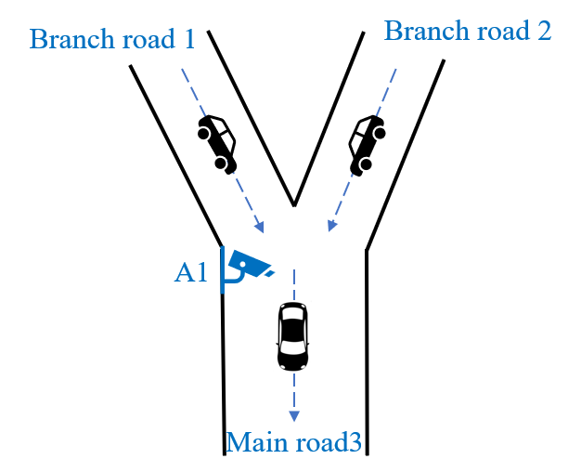

**Figure 1** Road schematic for Question 1

**Table 1.1** Function expression of branch traffic flow in Question 1

|  |  |
| --- | --- |
| Branch road 1 | Branch road 2 |
|  |  |

**Question 2:** Consider the road shown in Figure 2. The traffic flow of Branch road 1 and Branch road 2 converges into Main road 5 simultaneously, and the traffic flow of Branch road 3 and Branch road 4 converges into Main road 5 simultaneously. Only the traffic flow monitoring device A2 is installed on Main road 5, and the traffic flow information of the main road is recorded once every 2 minutes. The Table 2 in the Attachment provides the traffic flow data on Main road 5 during the time period of [6:58,8:58] on a certain morning. Suppose the time it takes for the vehicle to travel from the intersection of Branch road 1 and Branch road 2 to A2 is 2 minutes, and the travel time of the vehicle from Branch road 3 and Branch road 4 to A2 is negligible.

According to the historical traffic flow observation records, it can be known that during the time period of [6:58,8:58], the traffic flow on Branch road 1 was stable. The traffic volume of Branch road 2 increased linearly during the time periods of [6:58,7:48] and [8:14,8:58], and remained stable during the time period of (7:48,8:14). The traffic volume of Branch road 3 shows a trend of linear growth first and then stabilization. The traffic volume on Branch road 4 shows a periodic pattern.

Please establish a mathematical model to infer the traffic flow on Branch road 1, Branch road 2, Branch road 3 and Branch road 4 based on the data in the attached Table 2. Use an appropriate functional relationship to describe the variation of the traffic flow on each branch road with time $t$ ($t∈[0,59]$), and analyze the error of the results. Fill in the specific function expressions in Table 2.1, and fill in the traffic flow values on each branch road at moment 7:30 and 8:30 respectively in Table 2.2.

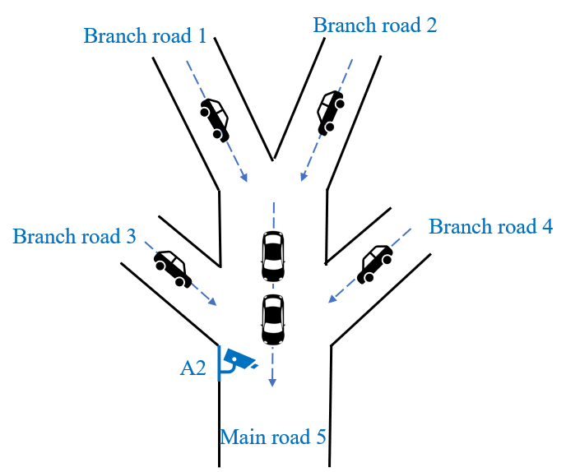

**Figure 2** Road schematic for Question 2

**Table 2.1** Function expression of branch traffic flow in Question 2

|  |  |
| --- | --- |
| Branch road 1 | Branch road 2 |
|  |  |
| Branch road 3 | Branch road 4 |
|  |  |

**Table 2.2** Numerical values of branch traffic flow in Question 2

|  |  |  |  |  |
| --- | --- | --- | --- | --- |
| Moment | Branch road 1 | Branch road 2 | Branch road 3 | Branch road 4 |
| 7:30 |  |  |  |  |
| 8:30 |  |  |  |  |

**Question 3:** Considering the road shown in Figure 3, the traffic flow of Branch road 1 and Branch road 2 simultaneously converges into Main road 4. Branch road 3 is a special traffic control road, and the vehicles on Branch road 3 are controlled by the traffic signal C when passing through the intersection. The red light time for C is set to 8 minutes, the green light time to 10 minutes, and the yellow light time is negligible. Only the traffic flow monitoring device A3 is installed on the Main road 4, recording the traffic flow information of the main road every 2 minutes. The traffic flow data of the Main road 4 on a certain morning [6:58,8:58] is provided in Table 3 of the Attachment. Suppose the driving time of the vehicle from the intersection of Branch road 1 and Branch road 2 to A3 is 2 minutes, and the driving time of the vehicle from Branch road 3 to A3 is negligible.

According to the historical traffic flow observation records, it can be known that during the time period of [6:58,8:58], the traffic flow on Branch road 1 showed a trend of "no traffic flow→ increase → decrease → stability → decrease to no traffic flow". The traffic volume of Branch road 2 increased linearly and decreased linearly during the time periods of [6:58,8:10] and [8:34,8:58] respectively, and remained stable during the time period of (8:10,8:34). When C shows a green light, the traffic flow on Branch road 3 either remains stable or shows a linear changing trend, and the first green light begins to light up at 7:06. When C shows a red light, the traffic volume on Branch road 3 is regarded as 0.

Please establish a mathematical model to infer the traffic flow on Branch road 1, Branch road 2 and Branch road 3 based on the data in the attached Table 3. Use an appropriate functional relationship to describe the variation of the traffic flow on each branch road with time $t$ ($t∈[0,59]$), and analyze the error of the results. Fill in the specific function expression in Table 3.1, and fill in the traffic flow values on each branch road at moment 7:30 and 8:30 respectively in Table 3.2.

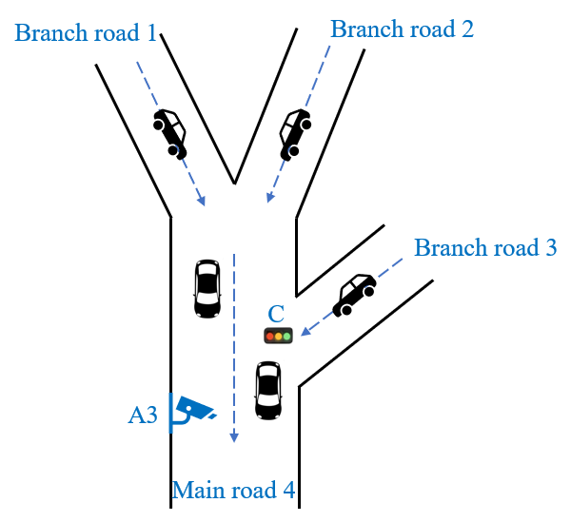

**Figure 3** Road schematic for Question 3

**Table 3.1** Function expression of branch traffic flow in Question 3

|  |  |
| --- | --- |
| Branch road 1 | Branch road 2 |
|  |  |
| Branch road 3 | |
|  | |

**Table 3.2** Numerical values of branch traffic flow in Question 3

|  |  |  |  |
| --- | --- | --- | --- |
| Moment | Branch road 1 | Branch road 2 | Branch road 3 |
| 7:30 |  |  |  |
| 8:30 |  |  |  |

**Question 4:** In the case of poor network signal, low visibility, large traffic flow or too fast traffic speed, traffic flow monitoring device may produce data errors. Considering the road shown in Figure 3, suppose that the data recorded by device A3 on a certain day has an error. The observed data within the time period of [6:58,8:58] are shown in Table 4 in the Attachment.

The traffic volume of Branch road 1 showed a trend of "no traffic flow→linear growth→stability→linear decrease to no traffic flow". The traffic volume of Branch road 2 increased linearly and decreased linearly during the time periods of [6:58,7:34] and [8:10,8:58] respectively, and remained stable during the time period of (7:34,8:10). The red light duration for signal light C is set to 8 minutes, the green light duration to 10 minutes, and the yellow light duration is negligible. When C shows a green light, the traffic flow on Branch road 3 is either stable or shows a linear changing trend. When C shows a red light, the traffic volume on Branch road 3 is regarded as 0. The time when C shows the green light is unknown.

Please establish a mathematical model to infer the actual traffic flow on Branch road 1, Branch road 2 and Branch road 3 based on the data in the attached Table 4. Use an appropriate functional relationship to describe the variation of the traffic flow on each branch road with time $t$ ($t∈[0,59]$), and analyze the error of the results. Fill in the specific function expression in Table 4.1, and fill in the traffic flow values on each branch road at moment 7:30 and 8:30 respectively in Table 4.2.

**Table 4.1** Function expression of branch traffic flow in Question 4

|  |  |
| --- | --- |
| Branch road 1 | Branch road 2 |
|  |  |
| Branch road 3 | |
|  | |

**Table 4.2** Numerical values of branch traffic flow in Question 4

|  |  |  |  |
| --- | --- | --- | --- |
| Moment | Branch road 1 | Branch road 2 | Branch road 3 |
| 7:30 |  |  |  |
| 8:30 |  |  |  |

**Question 5:** During certain time periods, the traffic flow on each branch road follows a specific functional trend. Therefore, there is no need to monitor traffic flow at every moment; it is sufficient to record traffic flow data at key moments to infer the functional expression of the traffic flow on each branch road throughout the entire time period.

Based on Question 2 and Question 3, please establish a mathematical model and answer the following: In order to obtain the functional expressions of the traffic flow on each branch road, at which specific moments during the time period [6:58, 8:58] should the monitoring devices on the main road record traffic flow data? Please fill in Table 5.1.

**Table 5.1** The results of Question 5

|  |  |
| --- | --- |
| Question | Observation moment |
| Question 2 |  |
| Question 3 |  |